# JS Back-End Retake Exam – Art Gallery

**Judge:** <https://judge.softuni.org/Contests/3309/JS-Back-End-Retake-Exam-14-Dec-2021>

## Exam rules:

1. You have **4 hours**
2. When you are ready, delete the ***node_modules***folder, make sure all dependencies are listed in the ***package.json*** file and submit your archiving project.
3. You are provided with **HTML & CSS** resources
4. You may **add attributes** (such as **class** and **dataset**), but it is forbidden to **change** **existing** attributes (such as **class** and **id**)
5. You may **change "href"** attributes on links and add/change the **method** and **action** attributes of HTML Forms.
6. Use **Express.js** as a back-end framework
7. Use **MongoDB** as a database with [**mongoose**](https://mongoosejs.com/docs/)
8. You can use whatever **view engine** you like ([**express-handlebars**](https://www.npmjs.com/package/express-handlebars), EJS, Pug, etc.…)
9. Use [**bcrypt**](https://www.npmjs.com/package/bcrypt) **for hashing the password**
10. The application **must start** from file **"index.js"** on port **3000**
11. It is **forbidden** to **use** **React**, **Vue**, **Angular,** etc.
12. **Only the last submission will be evaluated!**

## Application Overview

Get acquainted with the provided HTML and CSS and create an application for sharing masterpieces in an **art** **gallery**.

The visitors can view the **home page - ArtGallery** and **Gallery** with all art publications, they can also **register** witha **username**, **password**, and **address**, which will allow them to create their **art publications**, as well as **share** if interested (but only if the **current user** is **not** the **author**). Authors can **edit** or **delete** publications at any time.

## Functional Requirements

The Functional Requirements describe the functionality that the **application** must support.

### Guest (not logged in)

**Guest** navigation example:



The **application** should provide Guest (not logged in) users with the functionality to login, register, **view** the **ArtGallery** (homepage), **Gallery** (all publications), and the **Details** page.

### Users (logged in)

**User** navigation example:



The **application** should provide **Users** (logged in) with the functionality to:

* **View ArtGallery (home page) and all other pages with logged-in navigation**
* **View Gallery**
* **Create new publication [Create Publication]**
* **Access publication details page [Details]**
* **Share publication (if the current user is not the author of the publication)**
* **Delete or Edit publication depending on user's authentication (only for the author of the current publication)**

## Database Models

The **Database** of the **Art Gallery** application needs to support **2 entities.**

**Note**: **You can add additional properties to the models if this will help you solve the task**.

### User

* **Username** - string (required),
* Password - string (required),
* **Address -** string (required),
* **My Publications - a collection of Publication (a reference to the Publication Model)**

Note: When a user creates a new publication, a reference to that publication is added to that collection (My Publications).

### Publication

* **Title** - string (required),
* **Painting technique - string** (required),
* **Art picture** **- string** (required),
* **Certificate of authenticity - string** (**"Yes", "No"**) required,
* **Author - object Id (a reference to the User model),**
* Users Shared **- a collection of Users (a reference to the User model)**

Note: When a user shares a given publication, their id is added to that collection (**Users Shared**).

Implement the entities with the correct data types.

## Application Pages (80 pts)

**Note:** Don't forget to change the paths to the CSS files, and the images.

#### ArtGallery (for logged in users and logged-out users)

Preview **all** publications and user activity statistics. Each **publication** should display information about the **title**, and the **number of people shared the publication**, as well as the **[View publication] button** that leads to the **details** page for the specific publication.

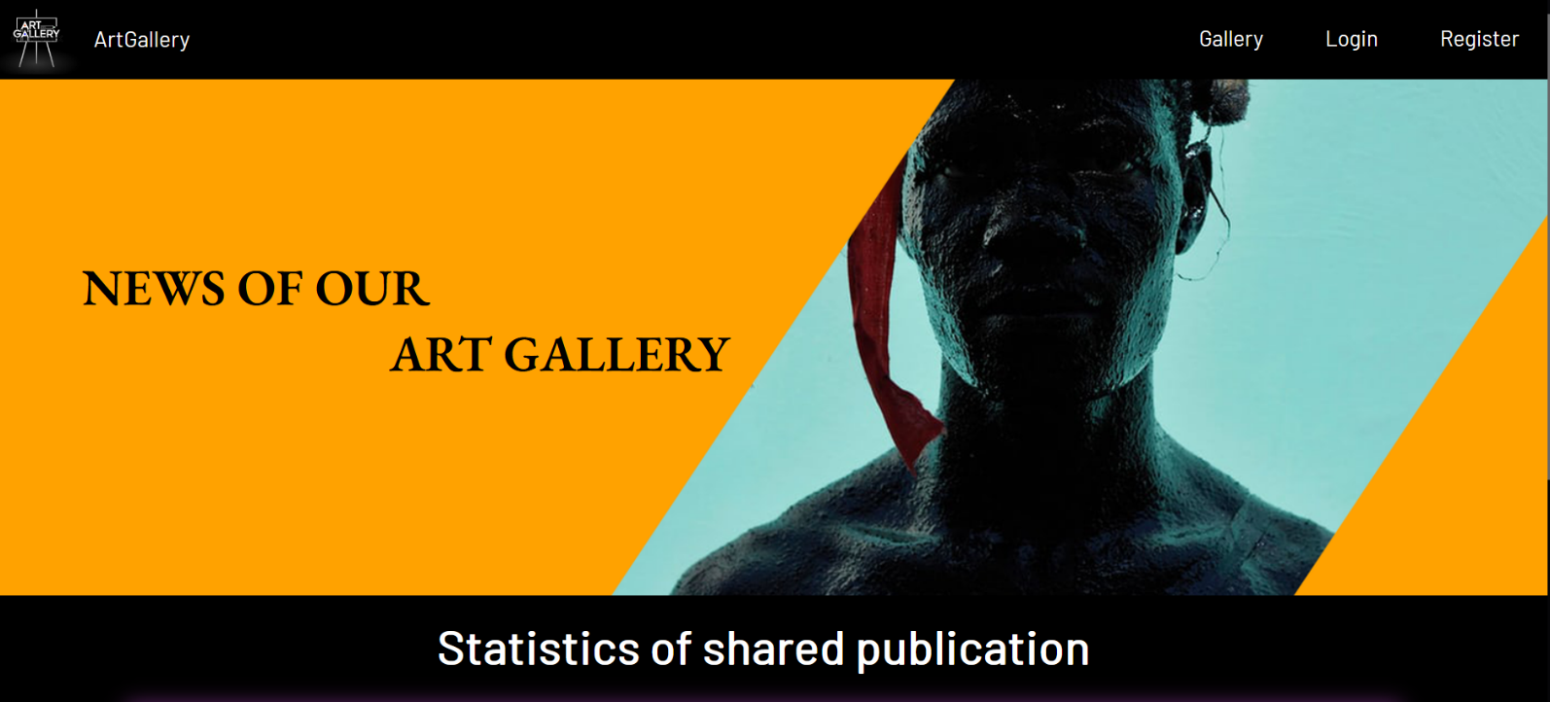

If there are NO publications yet, show the following view:

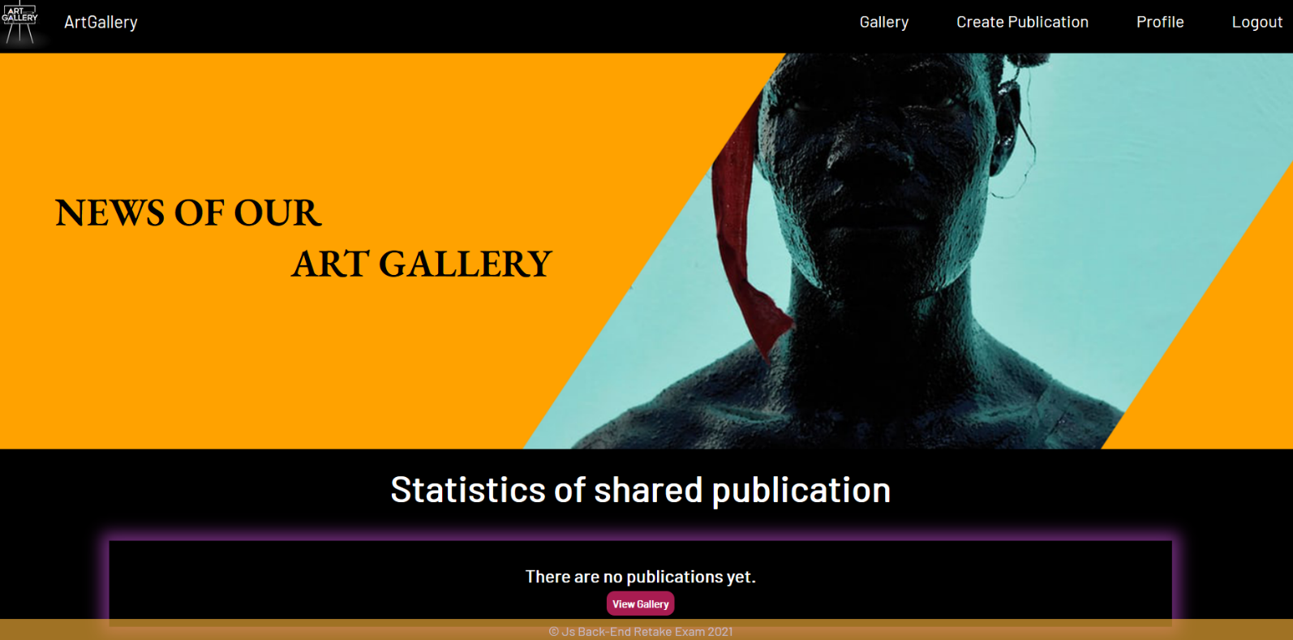

#### Register Page (logged out user)

Register a user inside the database with **username**, **password**, and **address**. **Password** inside the database must be **hashed** (use bcrypt) and both **passwords** must **match**! After successful registration **redirects to the ArtGallery (home page), with an already logged-in user**.

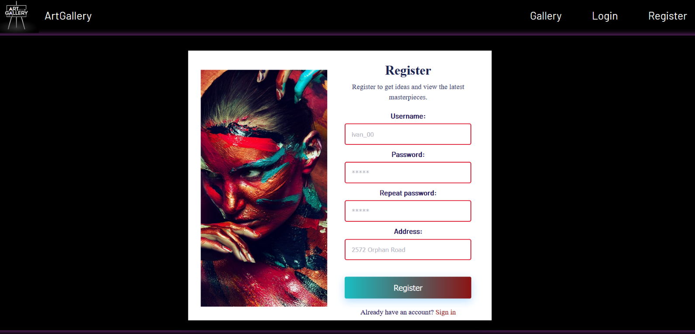

#### Login Page (logged out user)

Logging an already registered user with the correct **username** and **password**. After successful login **redirects to the ArtGallery (home page), with an already logged-in user**.

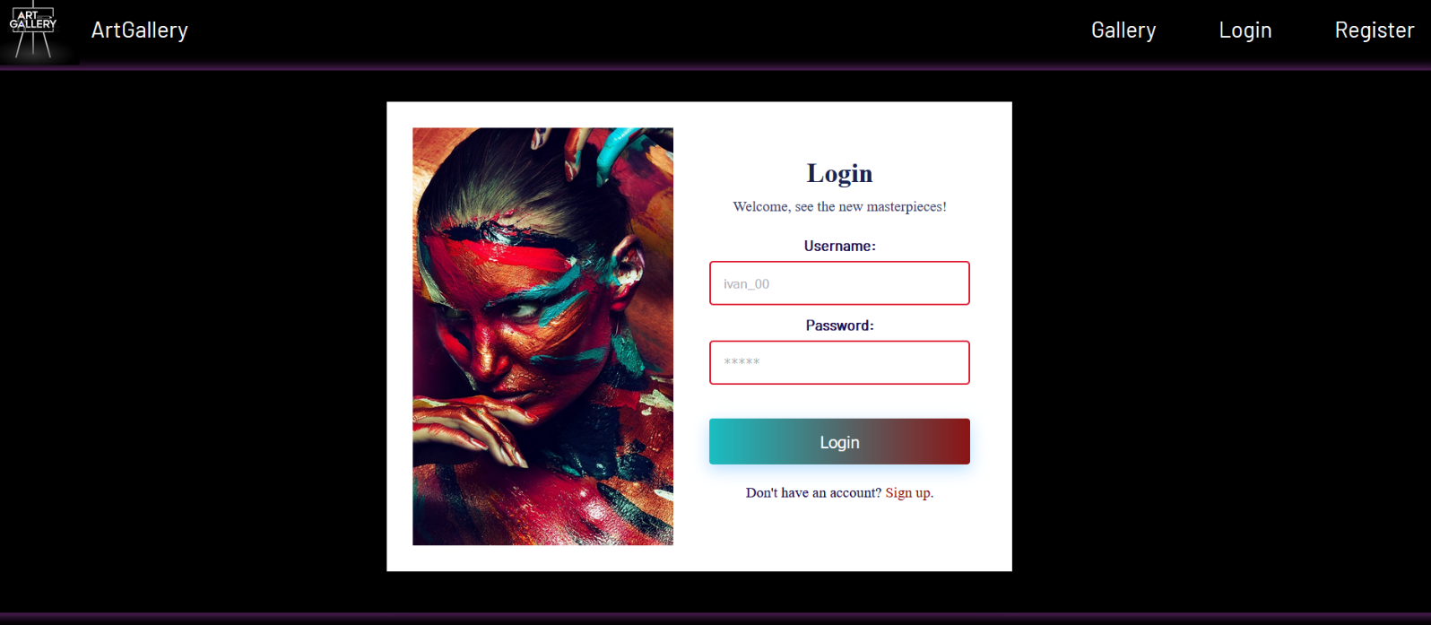

#### Logout (logged in user)

The logout action is available to **logged-in** users. Upon success, clear any session information and **redirect** the user to the **ArtGallery (home page)**.

#### Gallery (for logged in users and logged out users)

List of all **art publications**. **Each** **publication** should display information about the **art picture**, the **title**, the **certificate of authenticity**, as well as the [**Details**] button that leads to the details page for the specific publication. Like in the picture below:

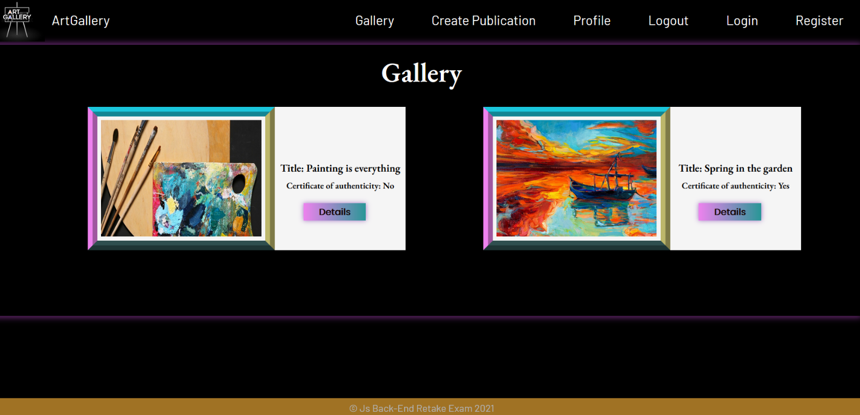

[**Details**] button should be a link to the **details** **page** for the current publication.

If **there are** **no** art publications in the **database**, display the following view:

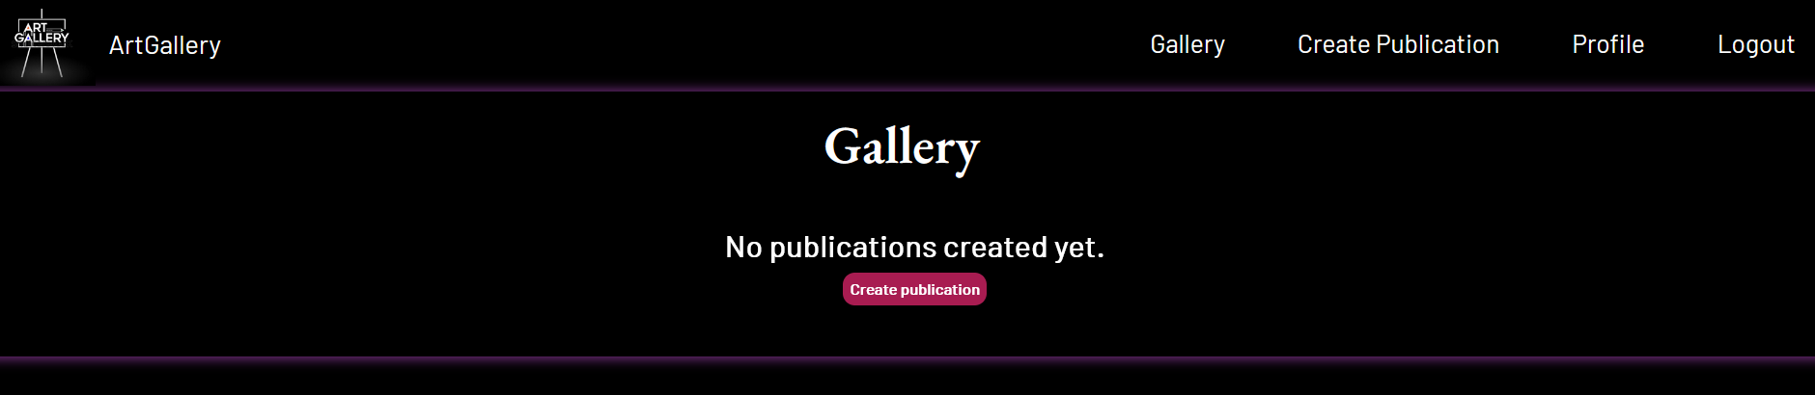

**Details Page - (for logged in users and logged out users)**

All users should be able to **view details** about thepublication. Clicking the **Details** button in a **publication card** should **display** the **Details** page. If the currently **logged-in user is the author** of the publication, the **Edit** and **Delete** buttonsshould be displayed, otherwise they should **not** be **available**.

Information about the publication:

* **Title**
* **Author**
* **Painting technique**
* **Certificate of authenticity**
* **Buttons** (Depending on the status of the currently logged in user)

#### Details Page (logged out users)

If there are **no logged**-in users, **no buttons** should be displayed.

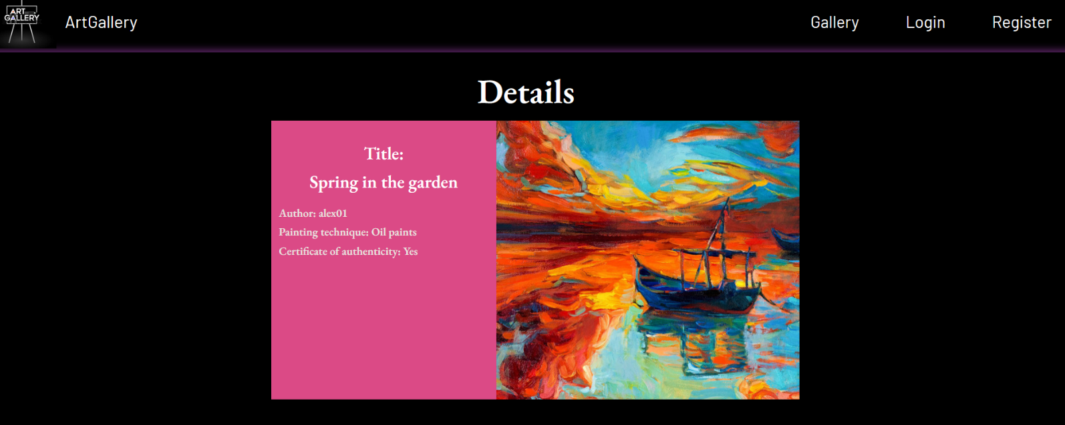

#### Details Page (logged in user and author of the current publication)

If the **currently logged-in** user is the **author** (the user who **created the art publication**), he should see the **[Edit]** and **[Delete]** buttons.

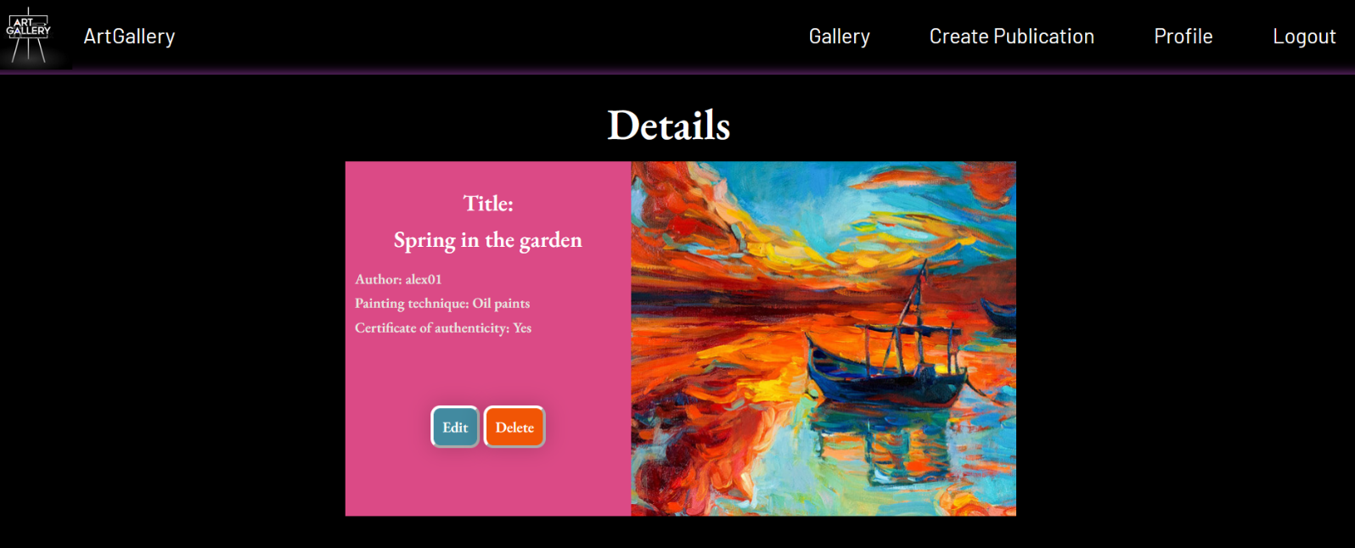

#### Details Page (logged in user who did not share publication)

If the currently logged-in user is **not the author** (the user that is not the creator for that publication) and has not shared this publication, he should see the **[Share publication]** button.

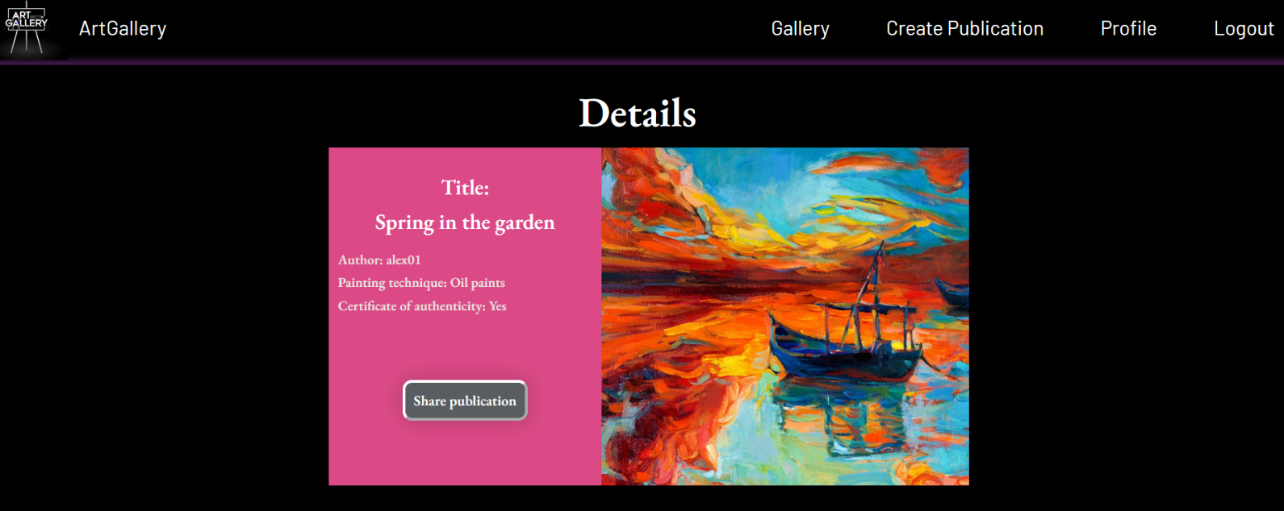

**Note:** In the photo shown, the [**Share publication**] button is not pressed, and the photo below (from the **ArtGallery page**) shows that there are no users who have shared the publication yet.



#### Details Page (logged in and has already shared a publication)

If the currently logged-in user is not **the author** and has **already shared** a current publication, he should see the paragraph [**You already shared this publication**].

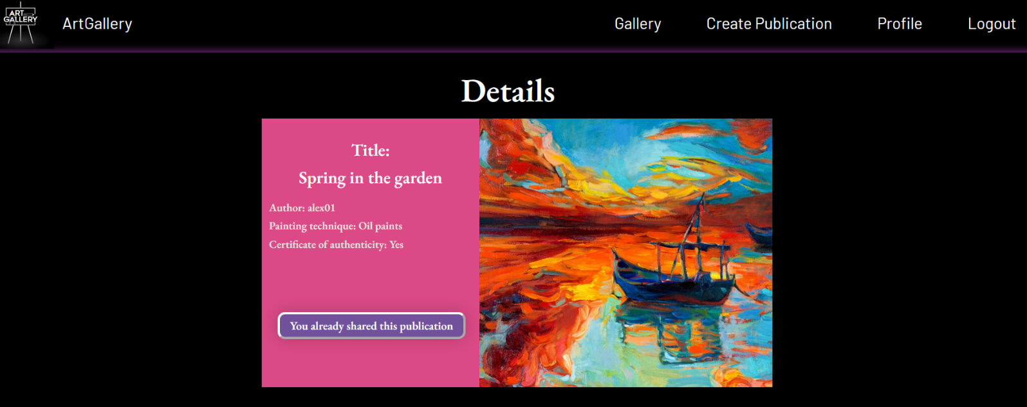

The photo below (from the **ArtGallery page**) should see the updated number as the user has already shared the publication.

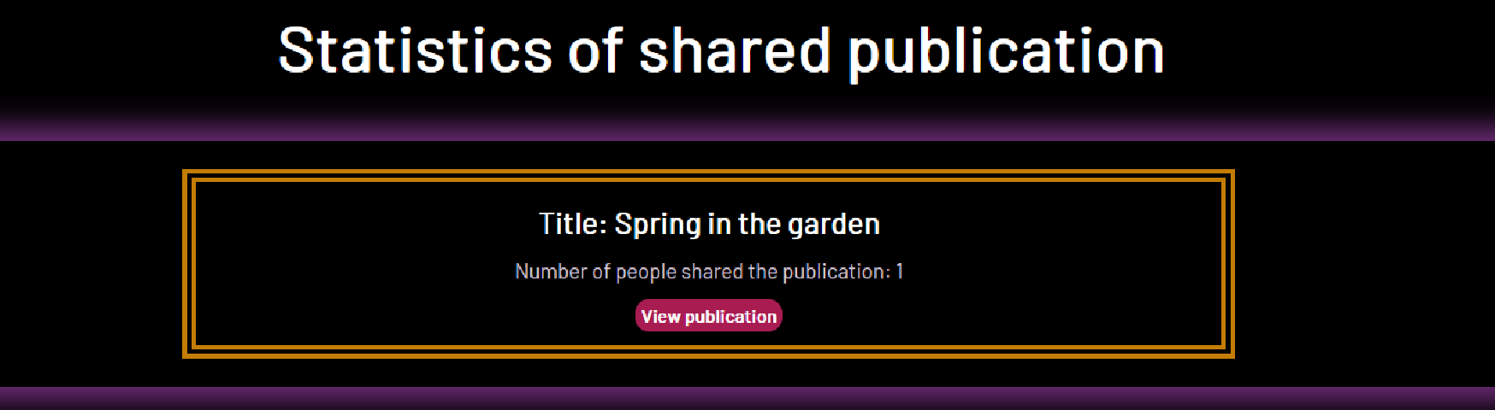

#### Share publication (logged in user who is not the author of the publication)

Any registered user who is not the **author** of the **art publication** must be able to share it (**if he has not already shared it**).

If it is successfully shared, the **userId** of the user must be added to the collection of Users Shared.

Then redirect the user to **ArtGallery (home page)**, where they should see the **updated** value of a **number of people shared the publication** for the current publication, and it will be incremented by one. (See the reflected changes for the publication in the section "**Shared Post Statistics**").

If a user has shared a current publication, he should see the paragraph "**You already shared this publication**".

#### Create Publication Page (logged in user)

The Create page is available to **logged-in users**. It contains a form for adding new **art publications**. Upon success, **redirect** the user to the **Gallery** page (all art publications).

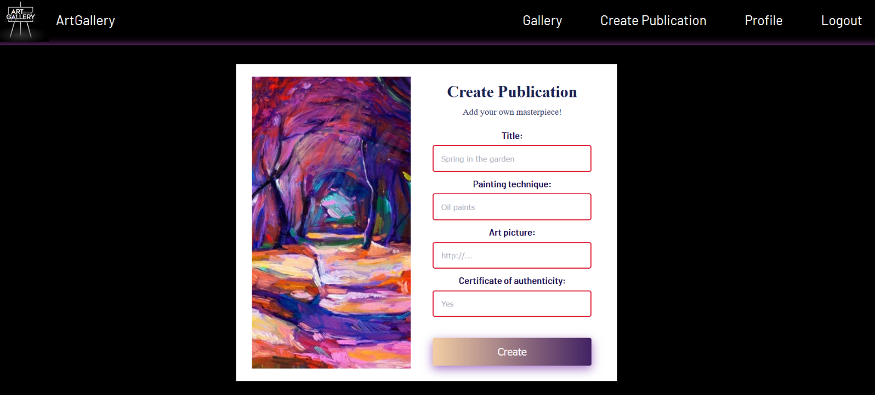

#### Delete Publication (logged in user and author of the current publication)

**Every author** should be able to click over the [**Delete**] **button** - deleting the current publication from the **database** and the user should be **redirected** to the **Gallery** page (all art publications).

#### Edit Publication (logged in user and author of the current publication)

The **Edit** page is available to logged-in users and it allows authors to **edit** their publications. Clicking the [**Edit**] **button** of a particular publication on the **Details** page should display the **Edit** page, with **all fields filled** with the data for the publication. It contains a form with input fields for all relevant properties. Upon success, **redirect** the user to the **Details** page for the current publication.

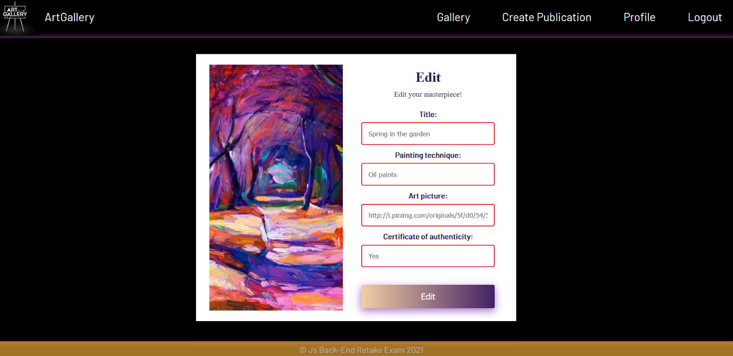

## Security Requirements (Routes Guards) - (10 pts)

The Security Requirements are mainly **access** requirements. Configurations about which users **can access** specific functionalities and pages.

* Guest (not logged in) users can access the **ArtGallery** (home page).
* Guest (not logged in) users can access the Login page and functionality.
* Guest (not logged in) users can access the Register page and functionality.
* Guest (not logged in) and Users (logged in) can access Gallery (listed all publications).
* Guest (not logged in) can access the **Details** page without functionality.
* Users (logged in) can access **ArtGallery** (home page).
* Users (logged in) can access the **Details** page and functionality.
* Users (logged in) can access **Create Publication** page and functionality.
* Users (logged in) can access to Share Publication functionality.
* Users (logged in and author of the current publication can access the Delete and Edit publication functionality.
* Users (logged in) can access Logout functionality.

If Guests (not logged in) trying to **access** а page that it should **not be able to**, you must **redirect** them to the **Login** page.

If **Users** (logged in) trying to **access** а page that it should **not be able to**, you must **redirect** them to the **ArtGallery**.

Use the following view for **invalid** **paths**:

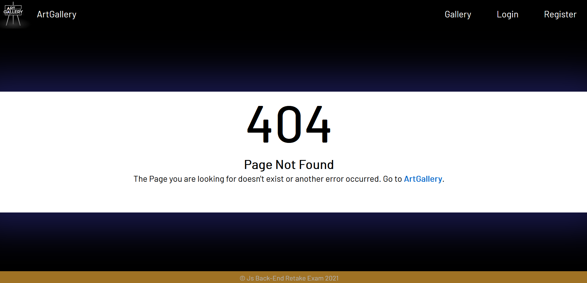

## Validation and Error Handling (10 pts)

The application should **notify** the users about the result of their actions.

In case of error, you **should display div** with class **"error-box"**.

**You can choose to display the first error or all of them. You have complete freedom to choose the content of the error message you will display.**

### Login / Register

You should make the following validations:

* The **username** should be **at least** **4 characters** long
* The **password** should be **at least 3 characters** long
* The **repeat password** should be **equal to the password**
* The **address** should be a maximum of **20 characters** long

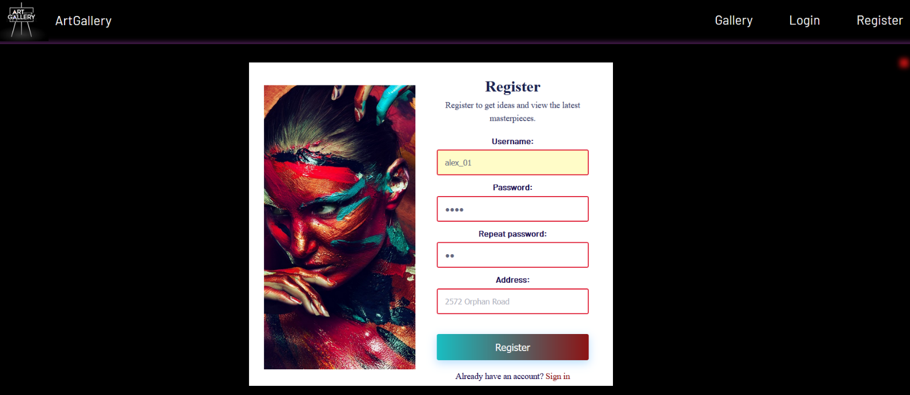

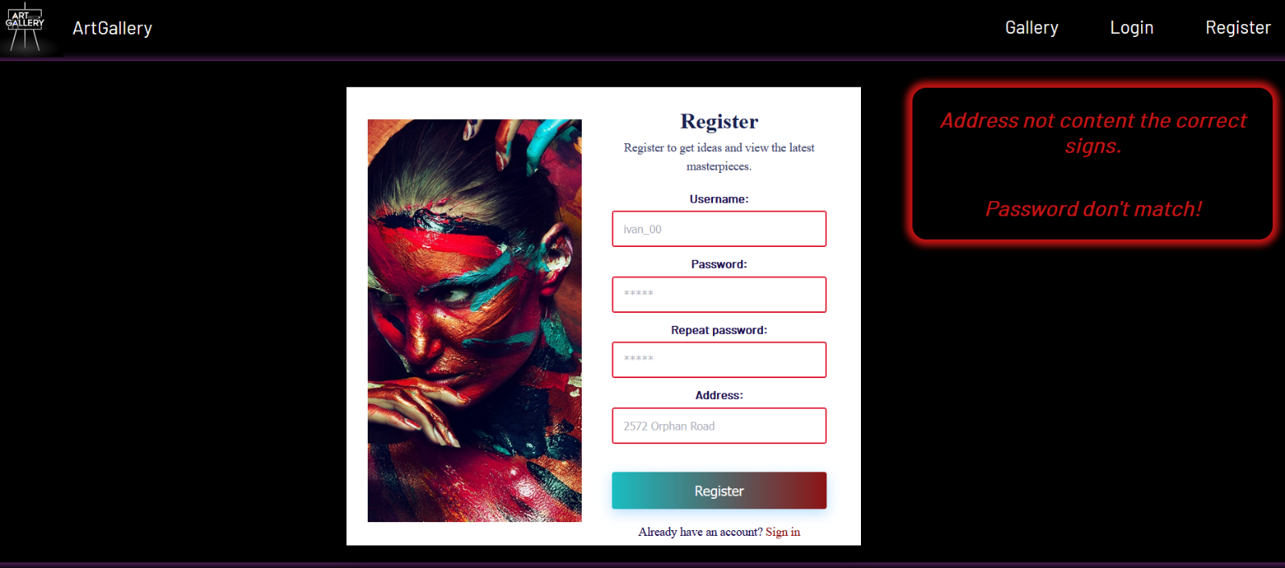

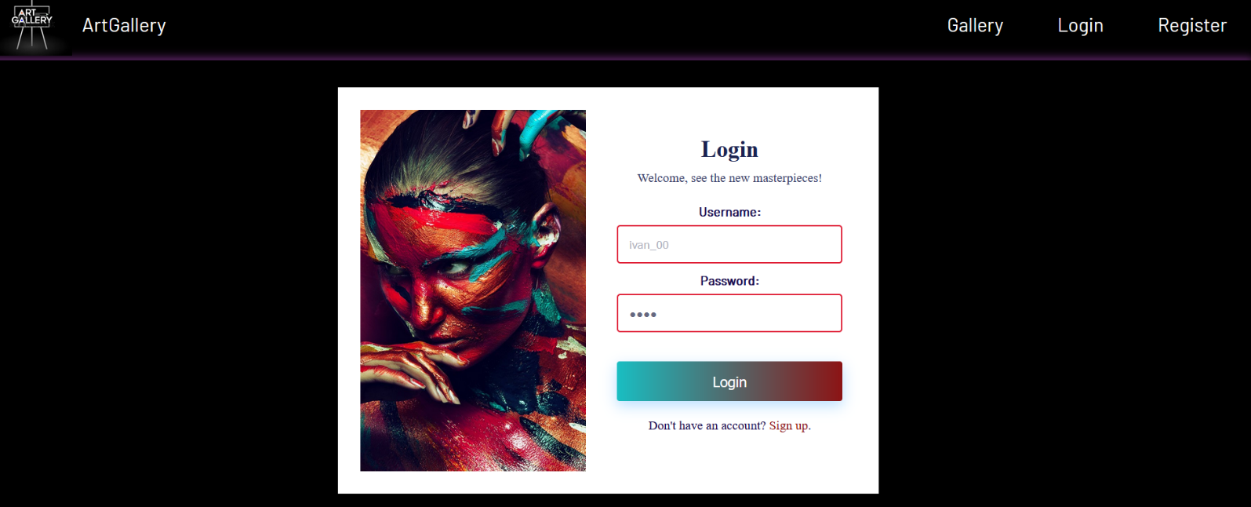

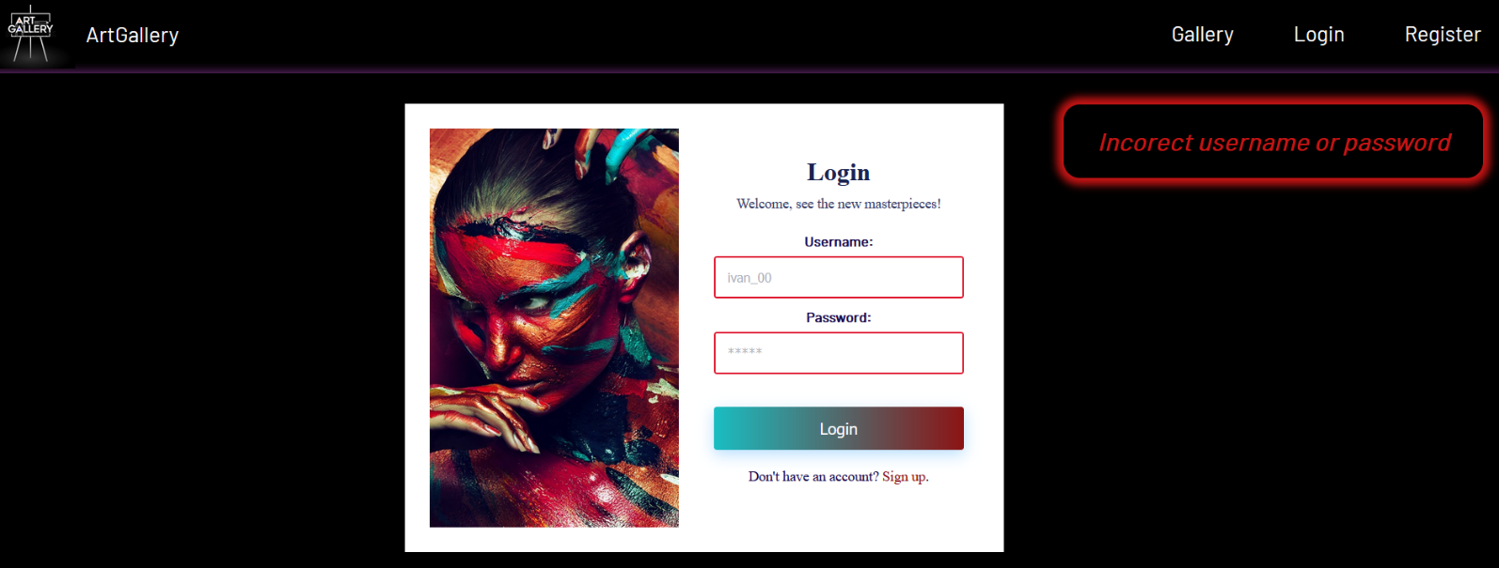

### Publication

You should make the following validations while **creating and editing a publication**:

* The **Title** should be a minimum of **6 characters** long.
* The **Painting technique** should be a maximum of **15 characters** long.
* The **Certificate of authenticity** there must be value **"Yes" or "No"**.
* The **Art picture** should start with **http:// or https://**.

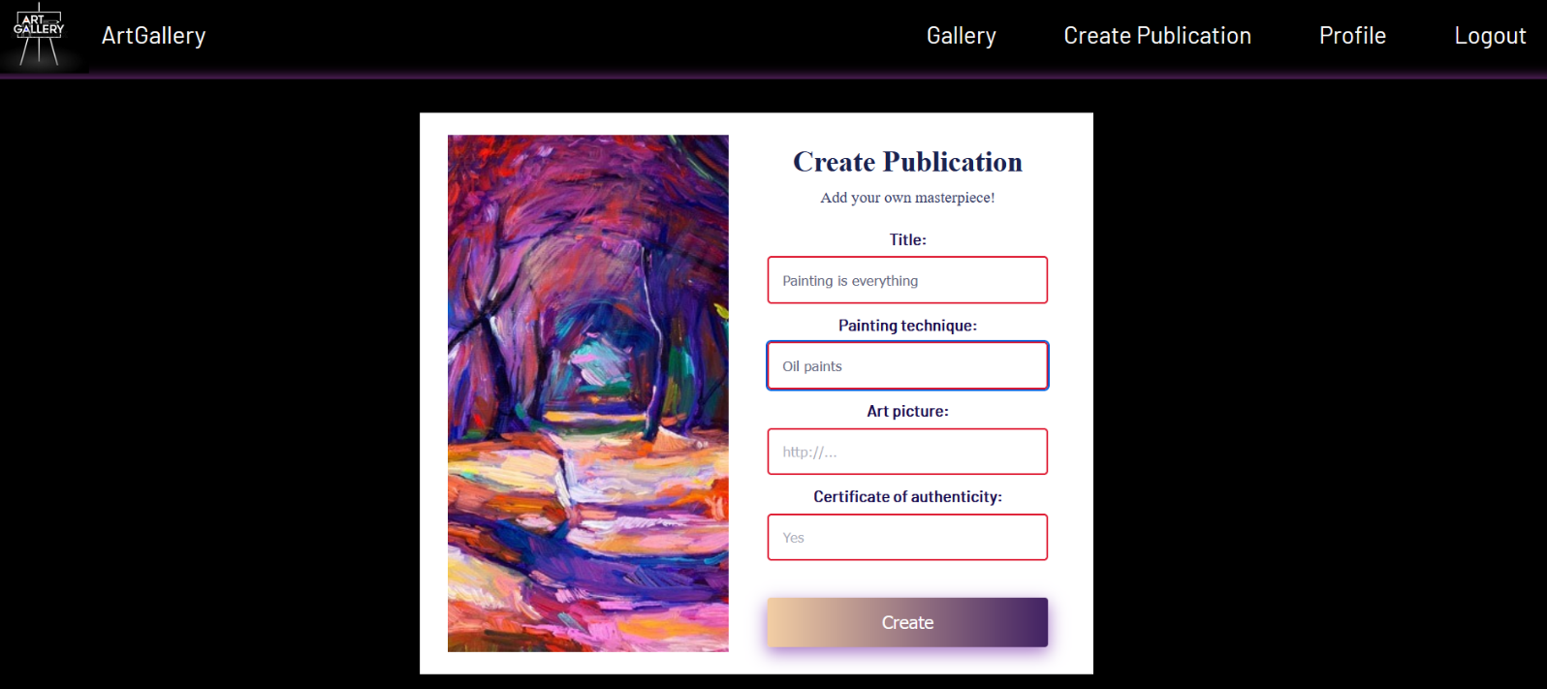

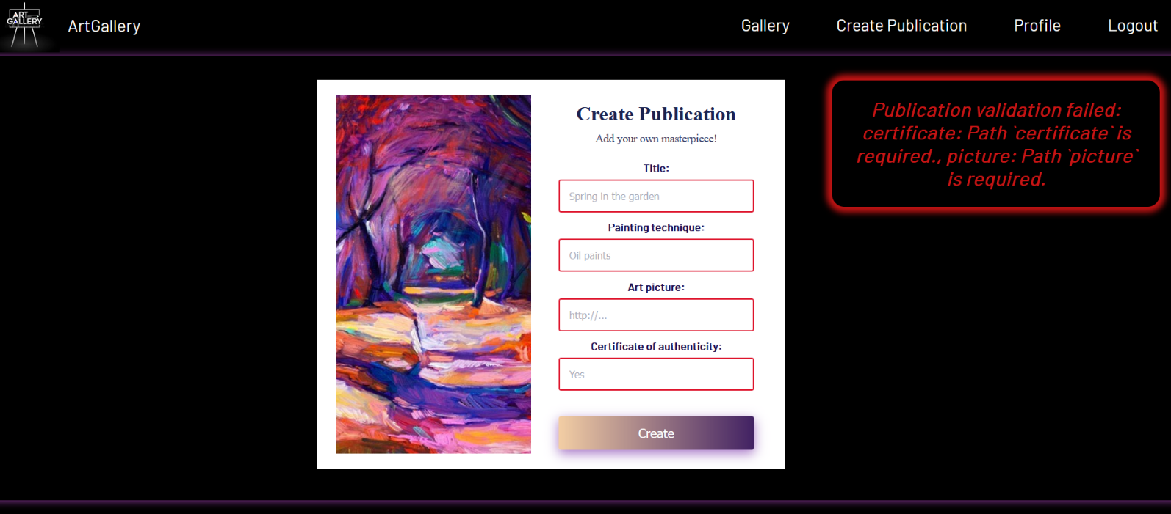

## Bonus - Profile (10 pts)

Each **logged-in** **user** should be able to view their full profile information by clicking [**Profile**]. **Username**, **address, titles of shared posts by the user (**which the **current user** has **shared),** and the **titles of which the user is the author** with current user data must be completed.

If there are **shared** or **own publications** from the current user, separate their titles with a comma and a space **(, )**.

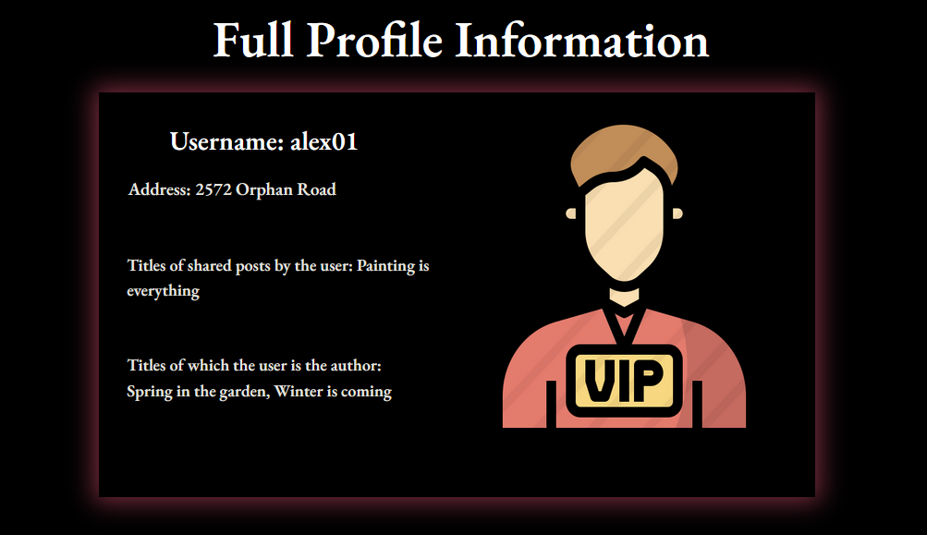

**Otherwise**, if there are **no shared** or **own publications** yet, the message **"Not yet."** should be visualized.

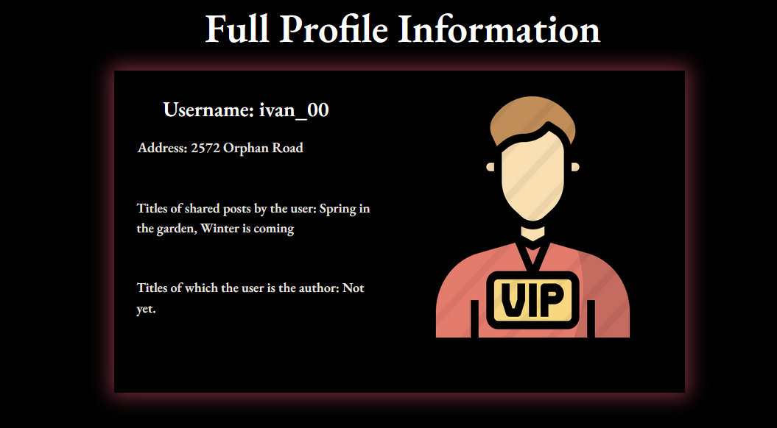

## Submitting Your Solution

Place in a **ZIP** file your project folder. Exclude the node_modules folder. Upload the archive to Judge.



*GOOD LUCK! 😊*